GitHub Task: Lexical Analyzer & Token Counter

Objective:
Develop a program that reads a source-code file and performs lexical analysis by identifying
and counting different types of tokens.
Problem Statement
Design and implement a Lexical Analyzer in C that reads a C statement as input and identifies the different types of tokens present in it. The program should classify each token as a keyword, identifier, operator, constant, string literal, or separator, display each token with its type, and finally calculate and display the count of each type of token and the total number of tokens.

Algorithm

Step 1: Start the program.
Step 2: Define a list of C language keywords such as int, float, if, else, return, while, for, etc.
Step 3: Read the source code input using fgets().
Step 4: Scan the input character by character until the end of the input.
Step 5: If the character is a whitespace, ignore it and move to the next character.
Step 6: If the character is an alphabet or underscore (_):
a. Read all following characters that are alphabets, digits, or underscores.
b. Form a complete word.
c. Check whether the word exists in the keyword list.
d. If it is a keyword, classify it as Keyword.
e. Otherwise, classify it as Identifier.
f. Increment the corresponding counter and total token count.
Step 7: If the character is a digit:
a. Read the complete numeric value.
b. Classify it as a Constant.
c. Increment the constant counter and total token count
Step 8: If the character is a double quote ("):
a. Read characters until the closing double quote is found.
b. Classify the complete sequence as a String Literal.
c. Increment the string literal counter and total token count.
Step 9: If the character is an operator (+, -, *, /, =, <, >, etc.):
a. Check whether it forms a two-character operator such as ==, <=, >=, or !=.
b. Classify it as an Operator.
c. Increment the operator counter and total token count.
Step 10: If the character is a separator such as ;, ,, (, ), {, }, [, ]:
a. Classify it as a Separator.
b. Increment the separator counter and total token count.
Step 11: Ignore any unknown or unsupported characters.
Step 12: Display each identified token along with its token type.
Step 13: Display the final token count:
- Keywords
- Identifiers
- Operators
- Constants
- String Literals
- Separators
- Total Tokens
Step 14: Stop the program.

Source Code:
#include <stdio.h>
#include <string.h>
#include <ctype.h>

#define MAX 100

int isKeyword(char *word)
{
char keywords[][10] = {
"int", "float", "char", "double", "if",
"else", "for", "while", "do", "return",
"void", "main"
};

int n = sizeof(keywords) / sizeof(keywords[0]);

for (int i = 0; i < n; i++)
if (strcmp(word, keywords[i]) == 0)
return 1;

return 0;
}

int main()
{
char input[MAX];
int i = 0, tokenCount = 0;

/* Token category counters */
int keywords = 0;
int identifiers = 0;
int operators = 0;
int constants = 0;
int stringLiterals = 0;
int separators = 0;

printf("Enter a C statement:\n");
fgets(input, MAX, stdin);

while (input[i] != '\0')
{
/* Ignore whitespace */
if (isspace(input[i]))
{
i++;
continue;
}

/* String Literal */
if (input[i] == '"')
{
printf("\"");

i++;

while (input[i] != '"' && input[i] != '\0')
{
printf("%c", input[i]);
i++;
}

if (input[i] == '"')
{
printf("\"");
i++;
}

printf(" -> String Literal\n");

stringLiterals++;
tokenCount++;
}

/* Identifier or keyword */
else if (isalpha(input[i]) || input[i] == '_')
{
char word[20];
int j = 0;

while (isalnum(input[i]) || input[i] == '_')
word[j++] = input[i++];

word[j] = '\0';

if (isKeyword(word))
{
printf("%s -> Keyword\n", word);
keywords++;
}
else
{
printf("%s -> Identifier\n", word);
identifiers++;
}

tokenCount++;
}

/* Number / Constant */
else if (isdigit(input[i]))
{
char number[20];
int j = 0;

while (isdigit(input[i]) || input[i] == '.')
number[j++] = input[i++];

number[j] = '\0';

printf("%s -> Constant\n", number);

constants++;
tokenCount++;
}

/* Operators */
else if (strchr("+-*/%=<>!", input[i]))
{
char op[3];
op[0] = input[i];
op[1] = '\0';

/* Check two-character operators */
if ((input[i] == '=' || input[i] == '<' ||
input[i] == '>' || input[i] == '!') &&
input[i + 1] == '=')
{
op[1] = '=';
op[2] = '\0';
i++;
}

printf("%s -> Operator\n", op);

operators++;
tokenCount++;
i++;
}

/* Separators */
else if (strchr(";,(){}[]", input[i]))
{
printf("%c -> Separator\n", input[i]);

separators++;
tokenCount++;
i++;
}

/* Unknown character */
else
{
printf("%c -> Unknown\n", input[i]);
i++;
}
}

/* Token Count */
printf("\n========== TOKEN COUNT ==========\n");
printf("Keywords : %d\n", keywords);
printf("Identifiers : %d\n", identifiers);
printf("Operators : %d\n", operators);
printf("Constants : %d\n", constants);
printf("String Literals : %d\n", stringLiterals);
printf("Separators : %d\n", separators);
printf("---------------------------------\n");
printf("Total Tokens : %d\n", tokenCount);
printf("=================================\n");

return 0;
}

Sample Input:
int sum = a + b;
float average = sum / 2.0;

// Calculate average
if (average > 50)
printf("Pass");

Sample Output:
TOKEN TYPE
------------------------------------------------
int Keyword
sum Identifier
= Operator
a Identifier
+ Operator
b Identifier
; Separator
float Keyword
average Identifier
= Operator
sum Identifier
/ Operator
2.0 Constant
; Separator
if Keyword
( Separator
average Identifier
> Operator
50 Constant
) Separator
printf Identifier
( Separator
"Pass" String Literal
) Separator
; Separator

------------------------------------------------

Token Count
Keywords : 3
Identifiers : 7
Operators : 4
Constants : 2
String Literals: 1
Separators : 8

Test Cases:
Test Case 1:
Input:
int a = 10;
Keywords : 1
Identifiers : 1
Operators : 1
Constants : 1
Strings : 0
Separators : 1
Total Tokens : 5
Test Case 2:
Input:
int a=10,b=20;
Keywords : 1
Identifiers : 2
Operators : 2
Constants : 2
Strings : 0
Separators : 2
Total Tokens : 9
Test Case 3:
Input:
printf("Hello");
Keywords : 0
Identifiers : 1
Operators : 0
Constants : 0
Strings : 1
Separators : 3
Total Tokens : 5
Test Case 4:
Input:
int sum=a+b*10;
Keywords : 1
Identifiers : 3
Operators : 3
Constants : 1
Strings : 0
Separators : 1
Total Tokens : 9
Test Case 5:
Input:
if(a>=10) return 1;
Keywords : 2
Identifiers : 1
Operators : 1
Constants : 2
Strings : 0
Separators : 3
Total Tokens : 9
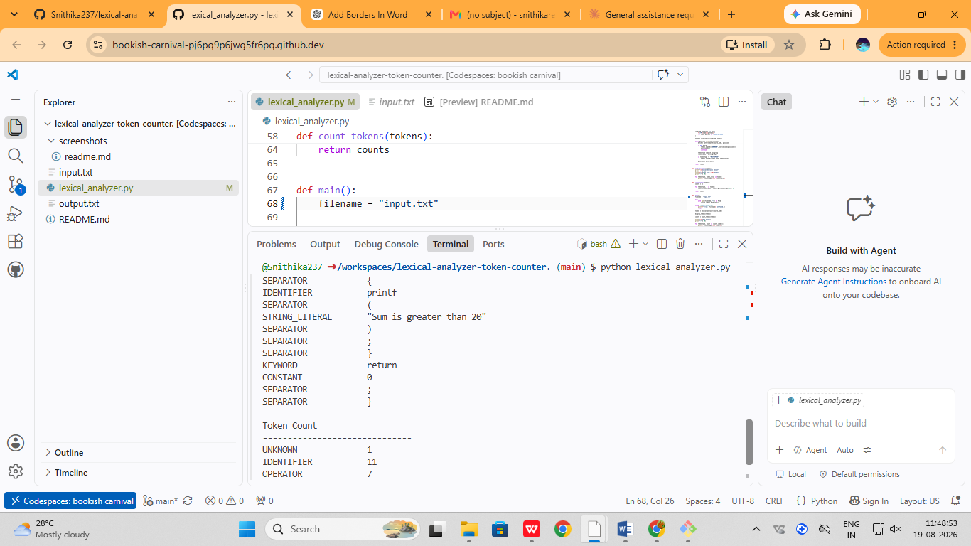

Conclusion:
The Lexical Analyzer program was successfully implemented in C to identify and classify different types of tokens present in a C statement. The program scans the input character by character and recognizes keywords, identifiers, operators, constants, string literals, and separators. It also maintains individual counts for each token category along with the total number of tokens.

